Steps by Step Detail Step for Assessment

**Step 1:** Spin up a scratch org/dev ed org. Since we will need to log into this org later, ensure it’s an Enterprise Edition scratch org so you can create a new System Administrator user later.

Solution:-   
Created scratch org/dev ed org. Made Additional changes as well.  
Added Edition as enterprise and updated person account as well in the sfdx-project.json  
{

  "packageDirectories": [

    {

      "path": "force-app",

      "default": true

    }

  ],

  "name": "ABCFashion",

  "sfdcLoginUrl": "https://login.salesforce.com",

  "sourceApiVersion": "62.0",

  "edition": "Enterprise",

  "features": ["PersonAccounts"],

  "settings": {

      "accountSettings": {

          "enablePersonAccounts": true

      }

  }

}

Credential for Dev org and url  
  
<URL:-> <https://bruntwork-dev-ed.develop.lightning.force.com/lightning/setup/SetupOneHome/home>  
  
username:-  [task.anjalichandwani@destinationrealestate.com](javascript:srcUp(%27%2F005WU000007u1v3%3Fnoredirect%3D1%26isUserEntityOverride%3D1%26isdtp%3Dp1%27);)  
  
password:- BruntWork@20#  
  
  
  
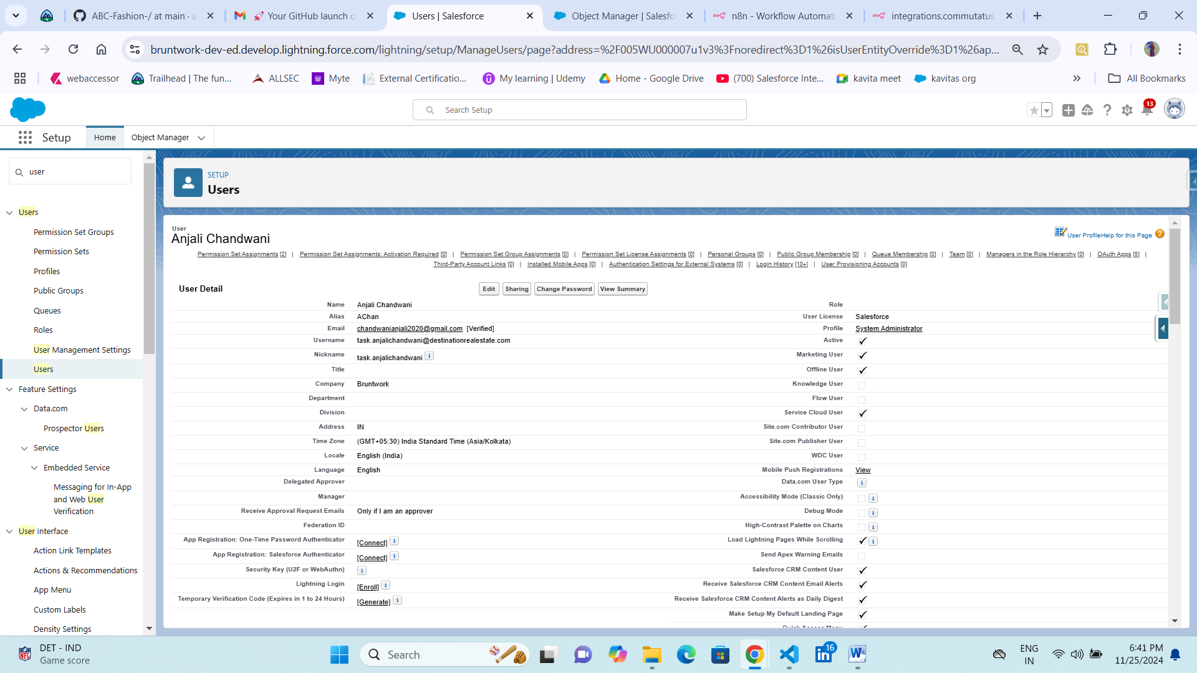

*This task involves designing processes for two people: a Sales Associate (user who has personal Salesforce credentials) and a customer (does not have a person account to log into Salesforce).*  
  
Created Sales Associate Profile who has personal salesforce credentials  
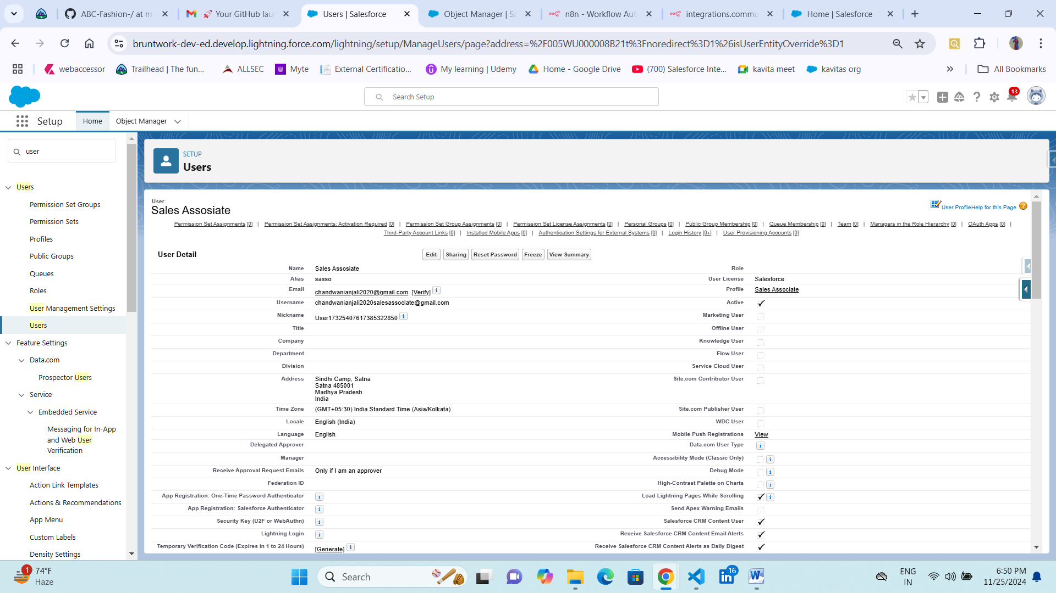  
  
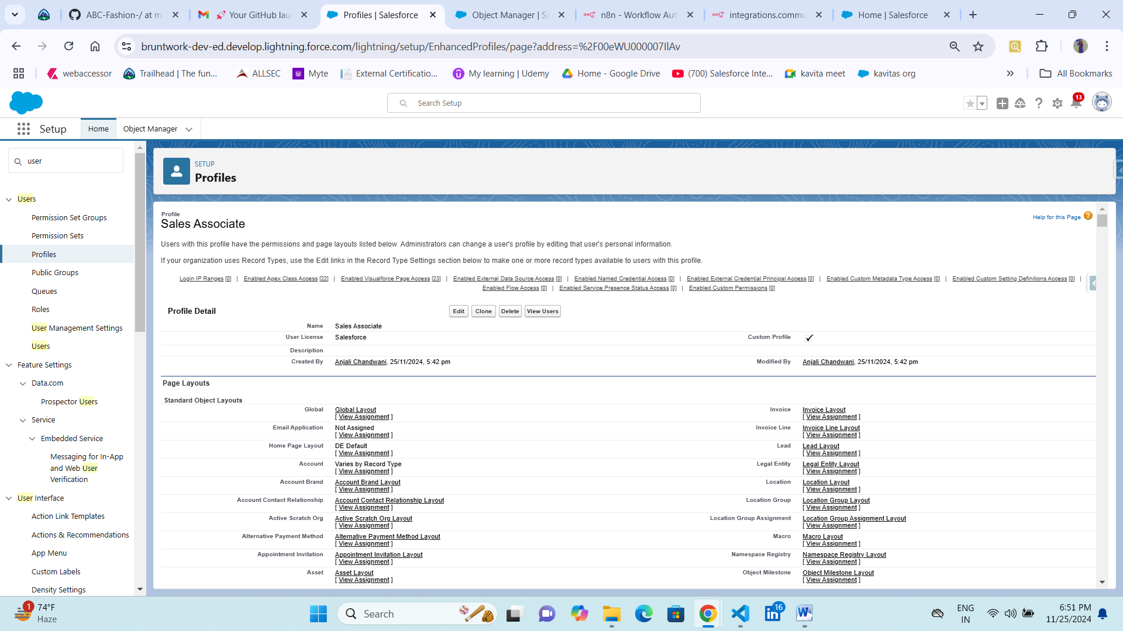

**Step 2:** Design a process where the sales associate who is currently logged into Salesforce can collect ONLY the following basic details from the customer and save it as a Person Account record:

* First Name
* Last Name
* Email
* Phone Number

The sales associate should not be presented with any other fields to fill while creating this record. However, they should be able to see other details like t-shirt size and shoe size when they open the customer record page.  
  
Solution:-  
  
Created a Screen Flow to have Better User Customer Interaction.  
  
Flow Name:- [New Customer Flow](javascript:void(0);)  
  
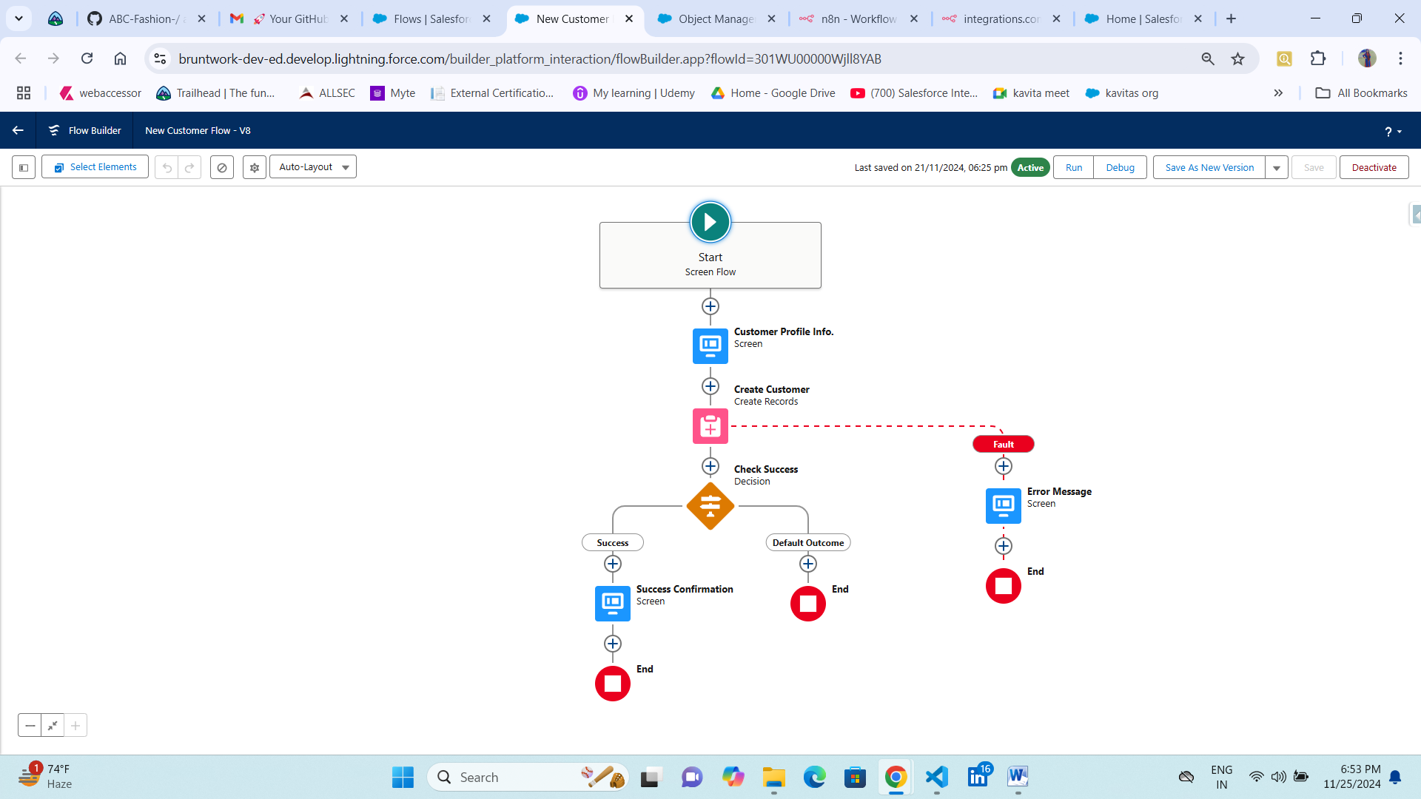  
Used Text for input box  
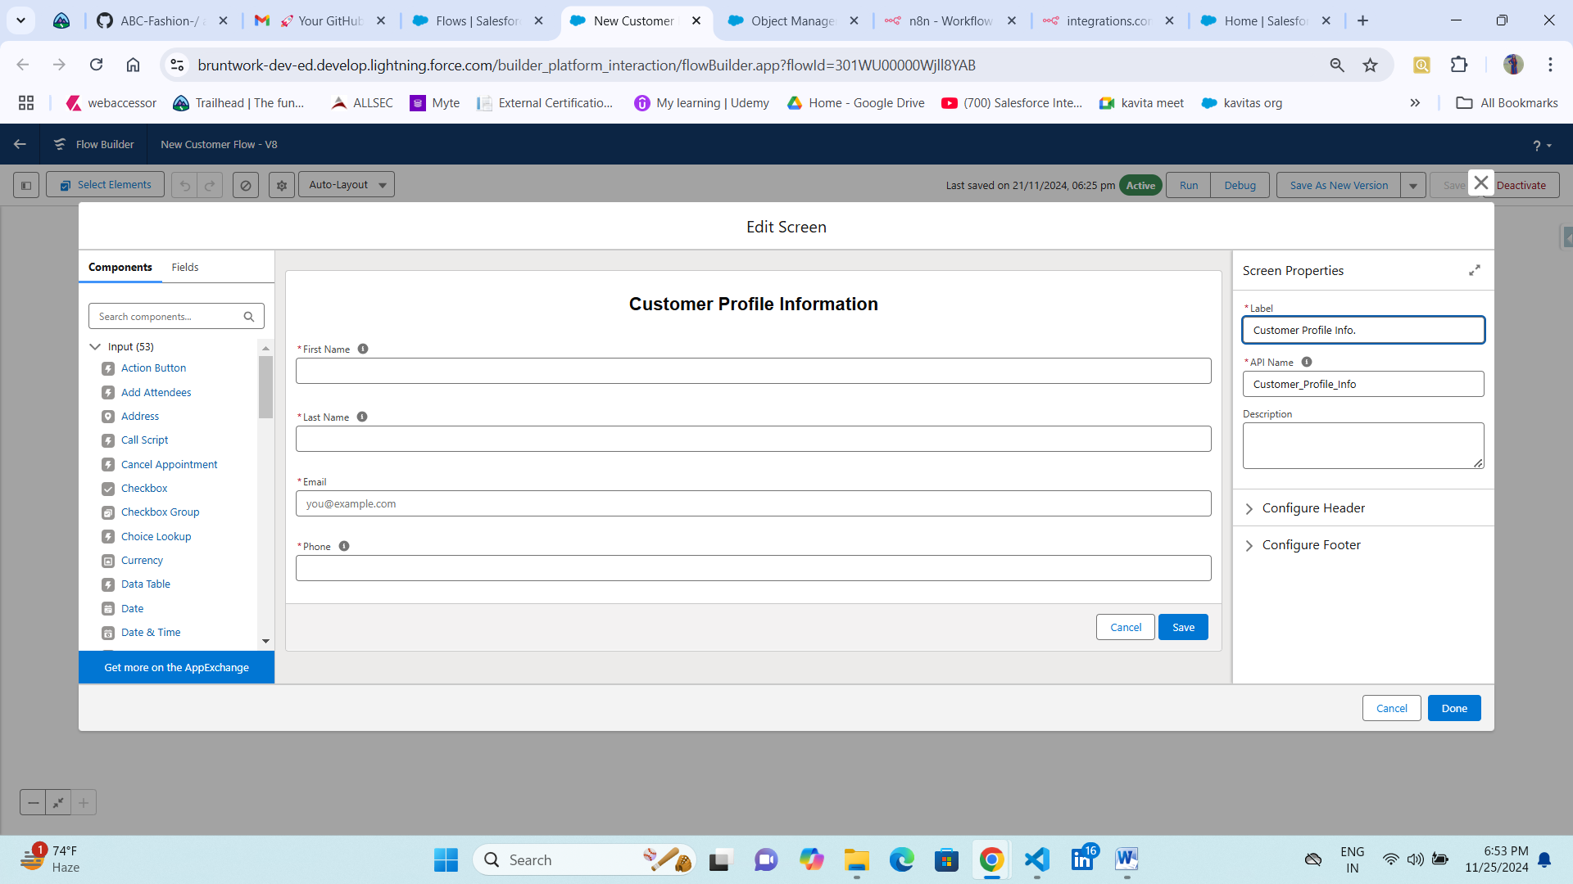

Mapped the fields FirstName, LastName, Email,Phone.  
  
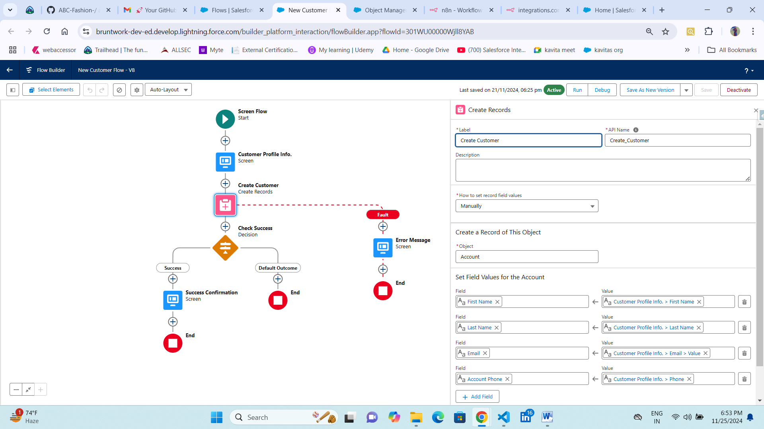

Decision for logic check  
  
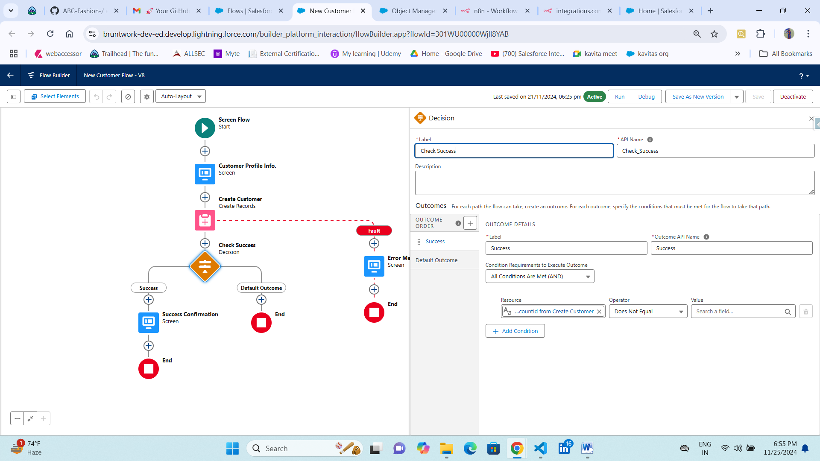  
  
Success Message  
  
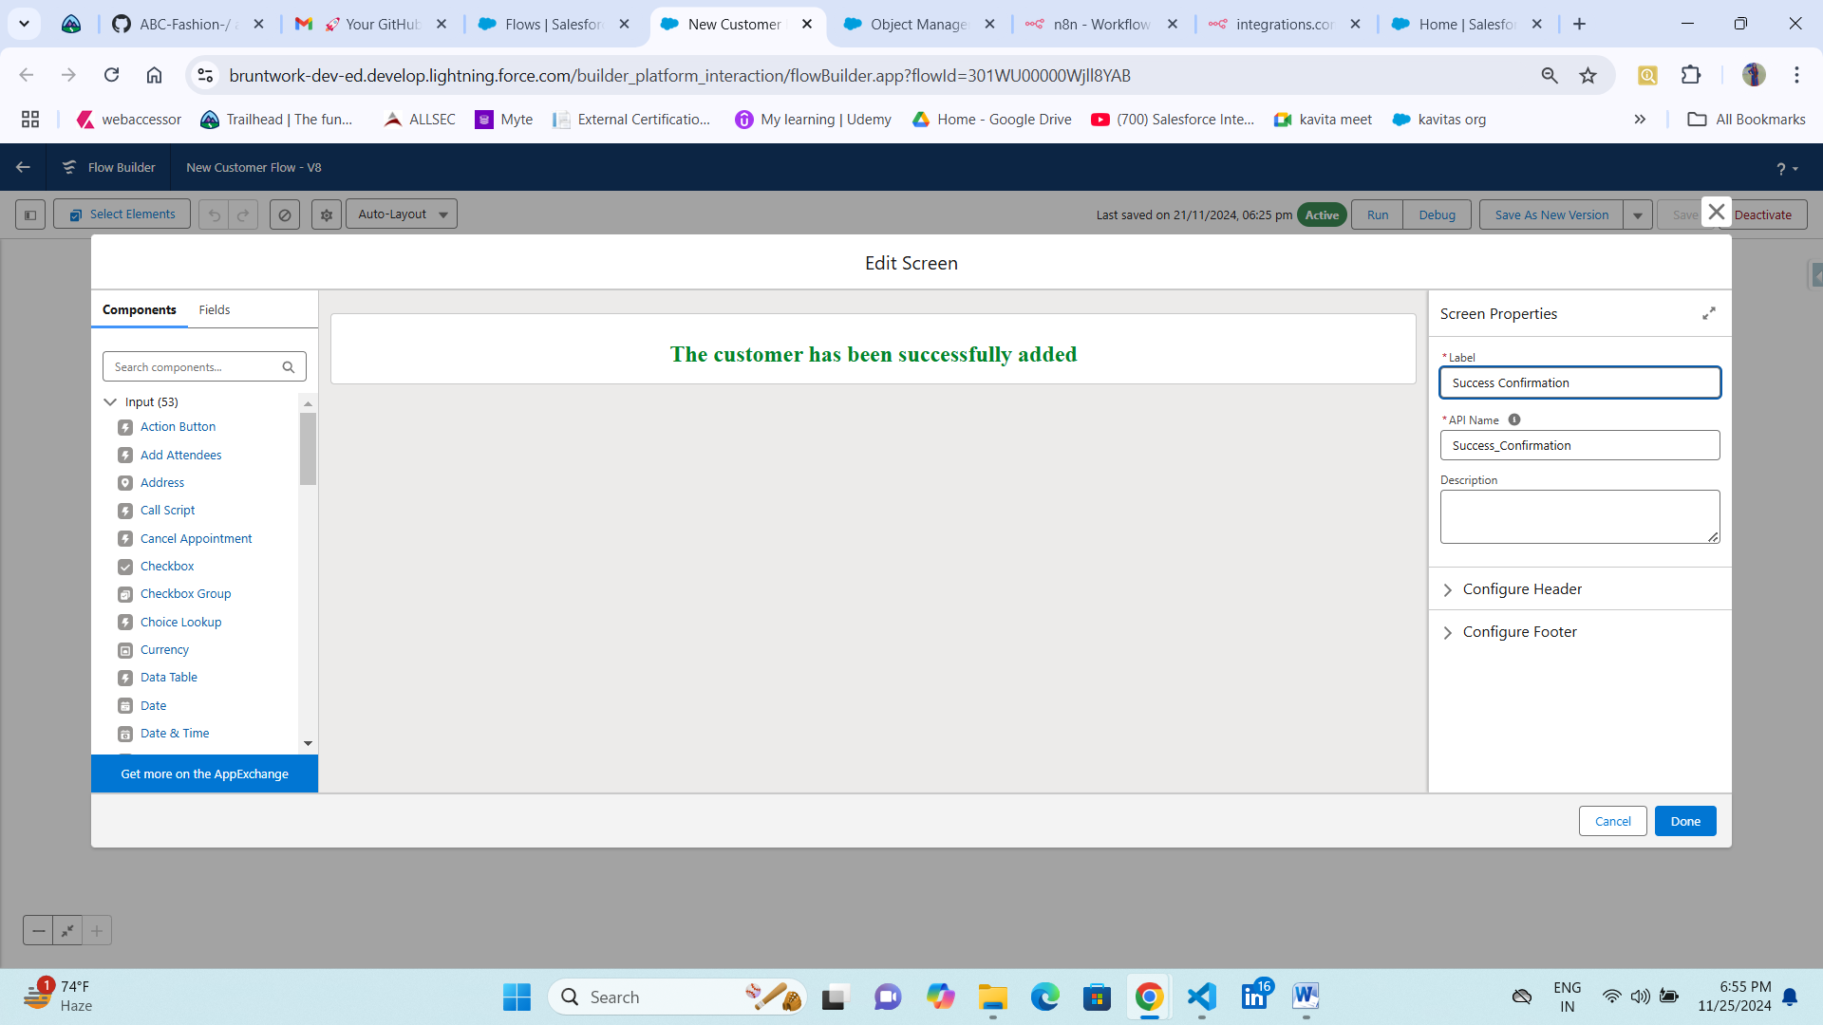  
Added Fault in create record to manage the exception or any errors occurs  
  
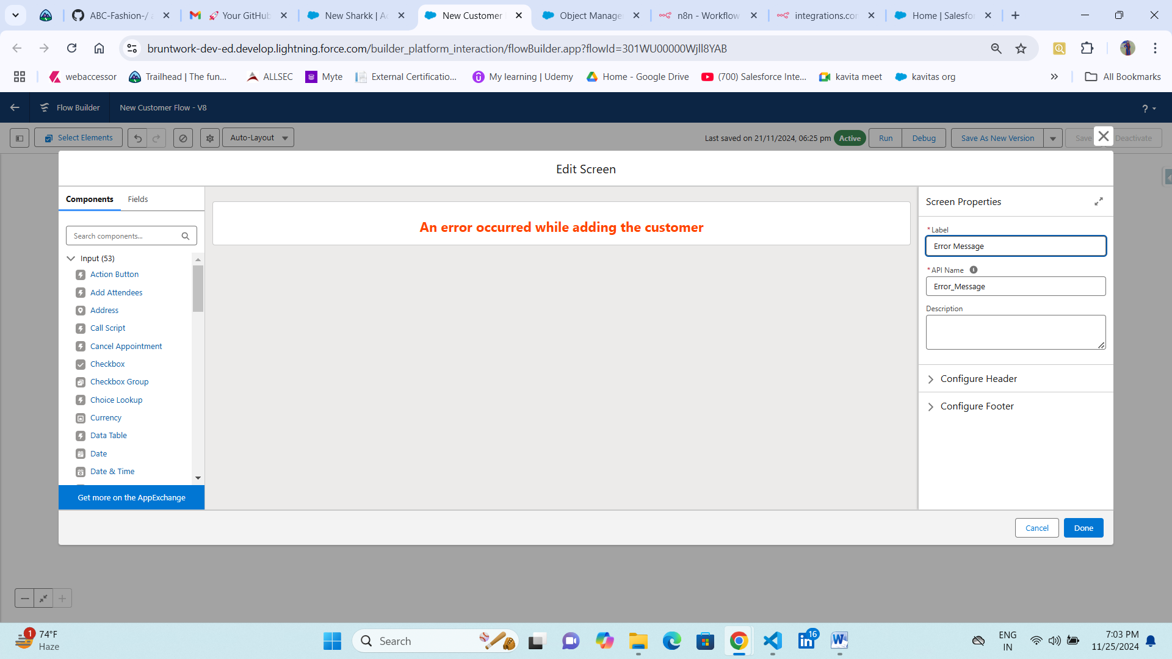  
  
  
Brunt work Profile Creation UI in salesforce backend for sales associate who have access  
The sales associate should not be presented with any other fields to fill while creating this record.  
  
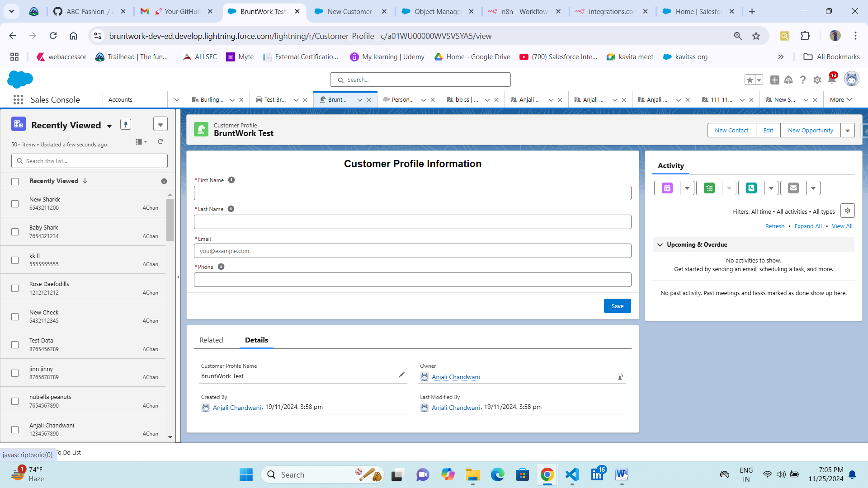  
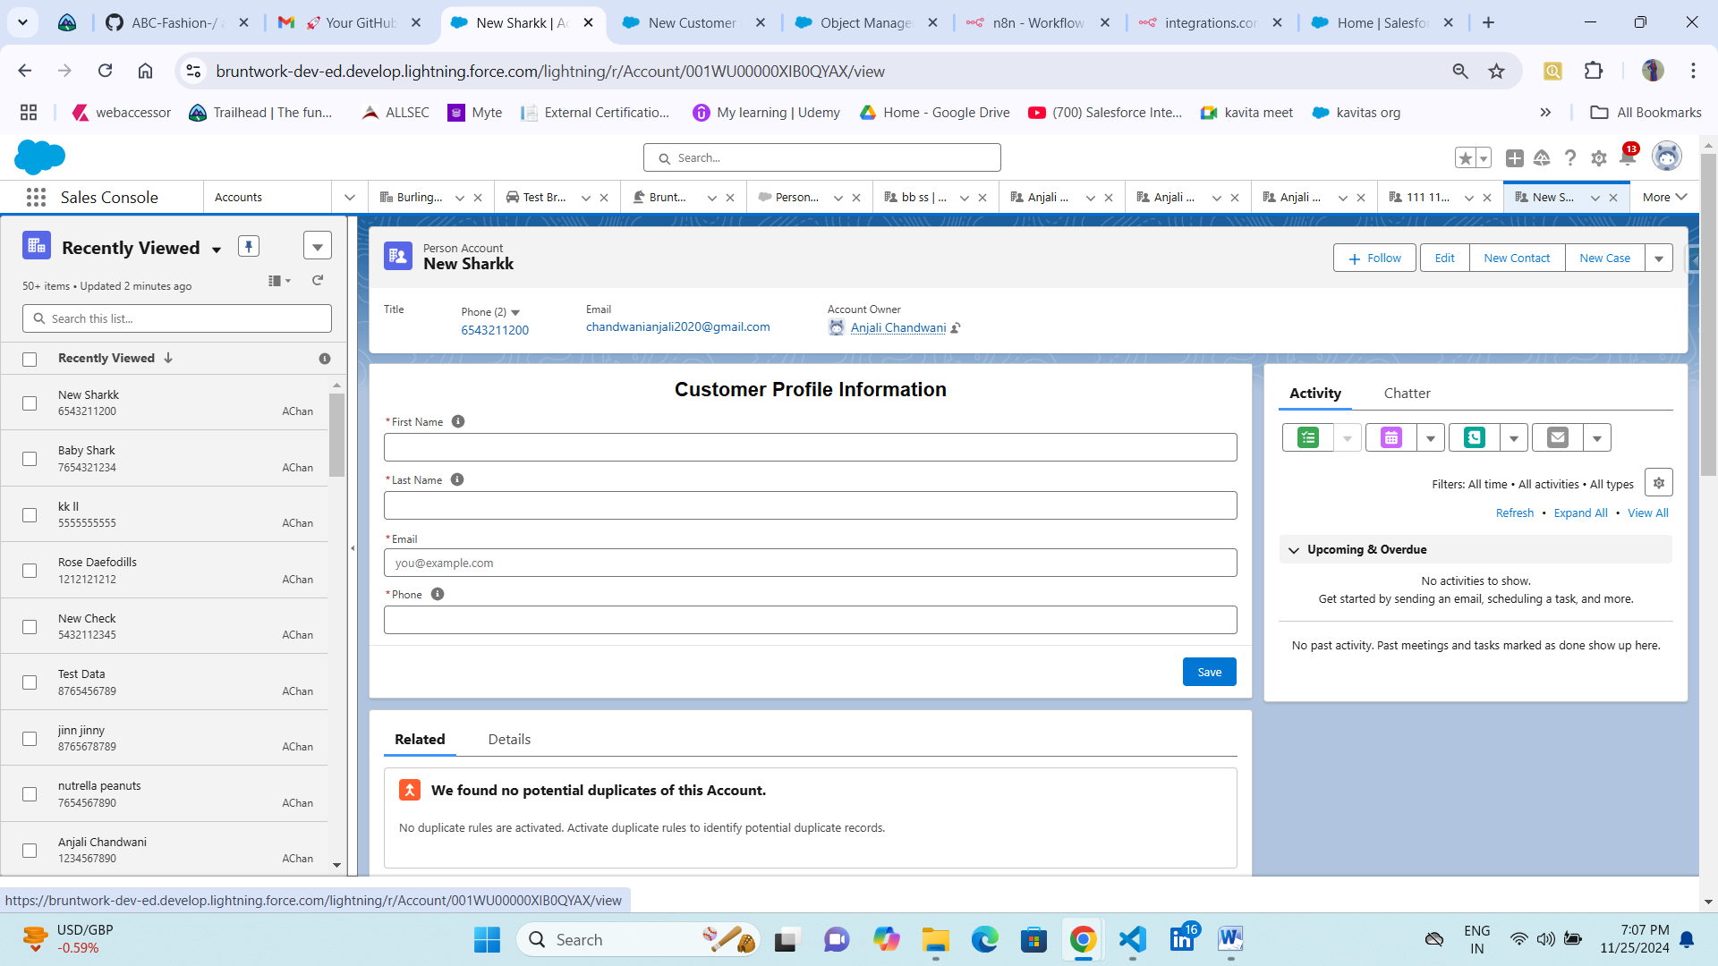

**Step 3:** Once the record is created, the customer will receive an email with a unique link to their profile. Clicking on this link will allow the customer to view their profile and

1. Be able to change their phone number
2. Be able to set their date of birth, t-shirt size and shoe size (all required fields)

The phone number should only accept 10-digit US/Canadian numbers.

The t-shirt sizes are: XS, S, M, L, XL, XXL

The shoe sizes are between 6 and 16 (inclusive), incrementing by 0.5.

⚠️ Remember, the customer doesn’t have access to Salesforce, so the link needs to be accessible to an unauthenticated user.

⚠️ Something to note is that Salesforce IDs have a predictable pattern. This means that if the link has the record Id as the only way to identify the customer’s profile, someone could just change a few letters in the URL to start accessing other customer profiles. **Please ensure that a plaintext record Id in the URL is not the sole identifier for the customer profile page.**

**Solution:-  
  
Record is Created in Backend**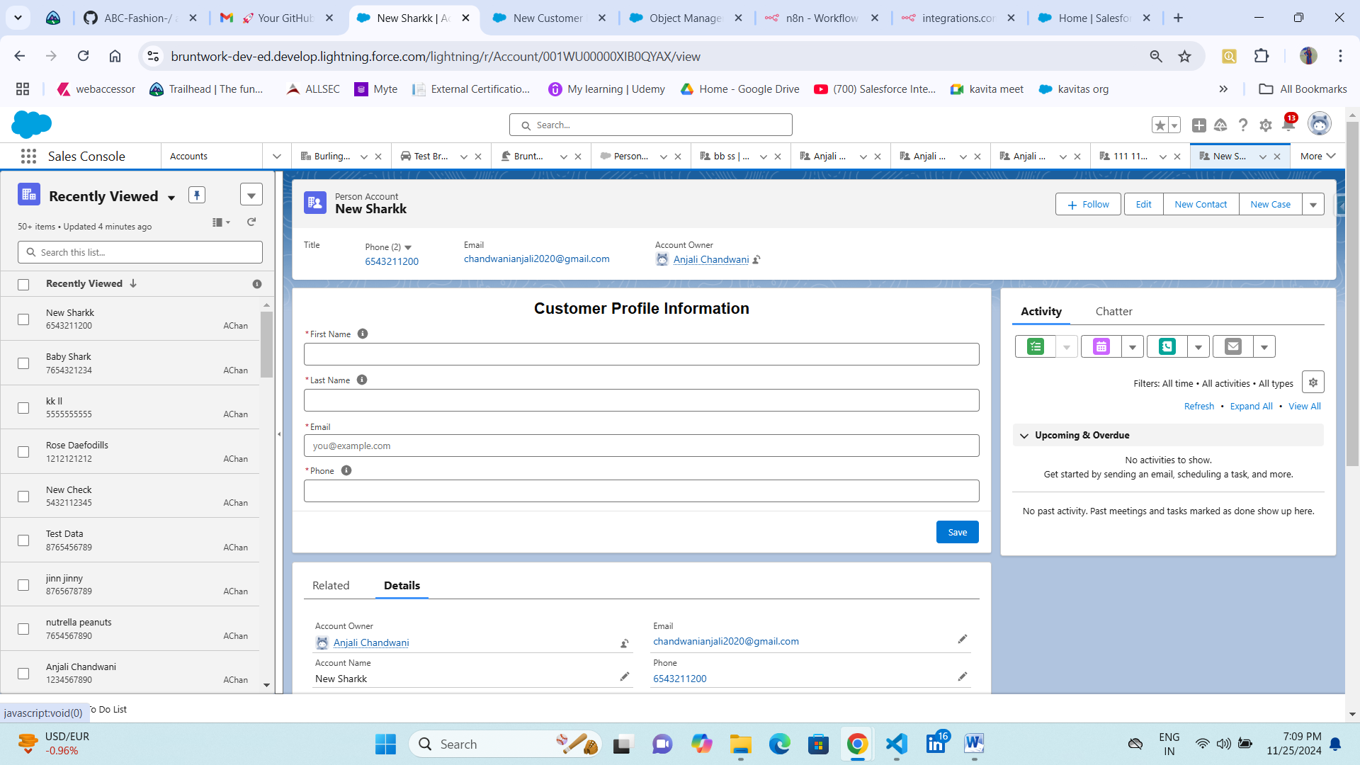

customer will receive an email with a unique link to their profile (securetoken to avoid malicious activity.)

Customer receives a mail with secure token at the end  
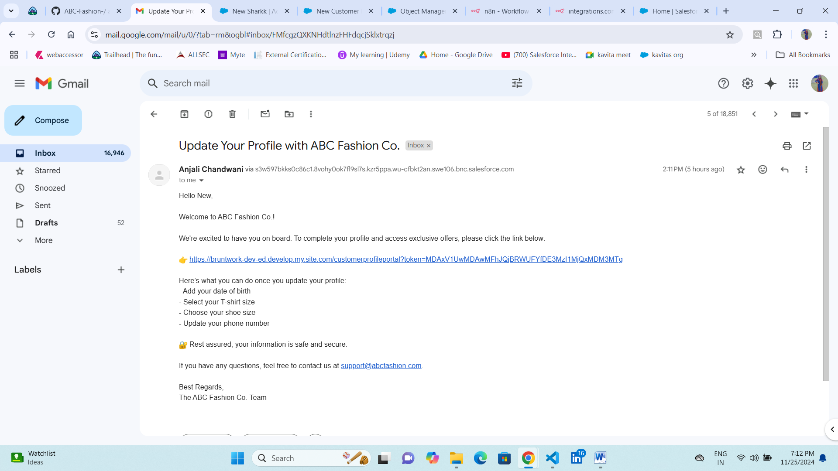 **Created LWR in experience sites for customerprofileportalpage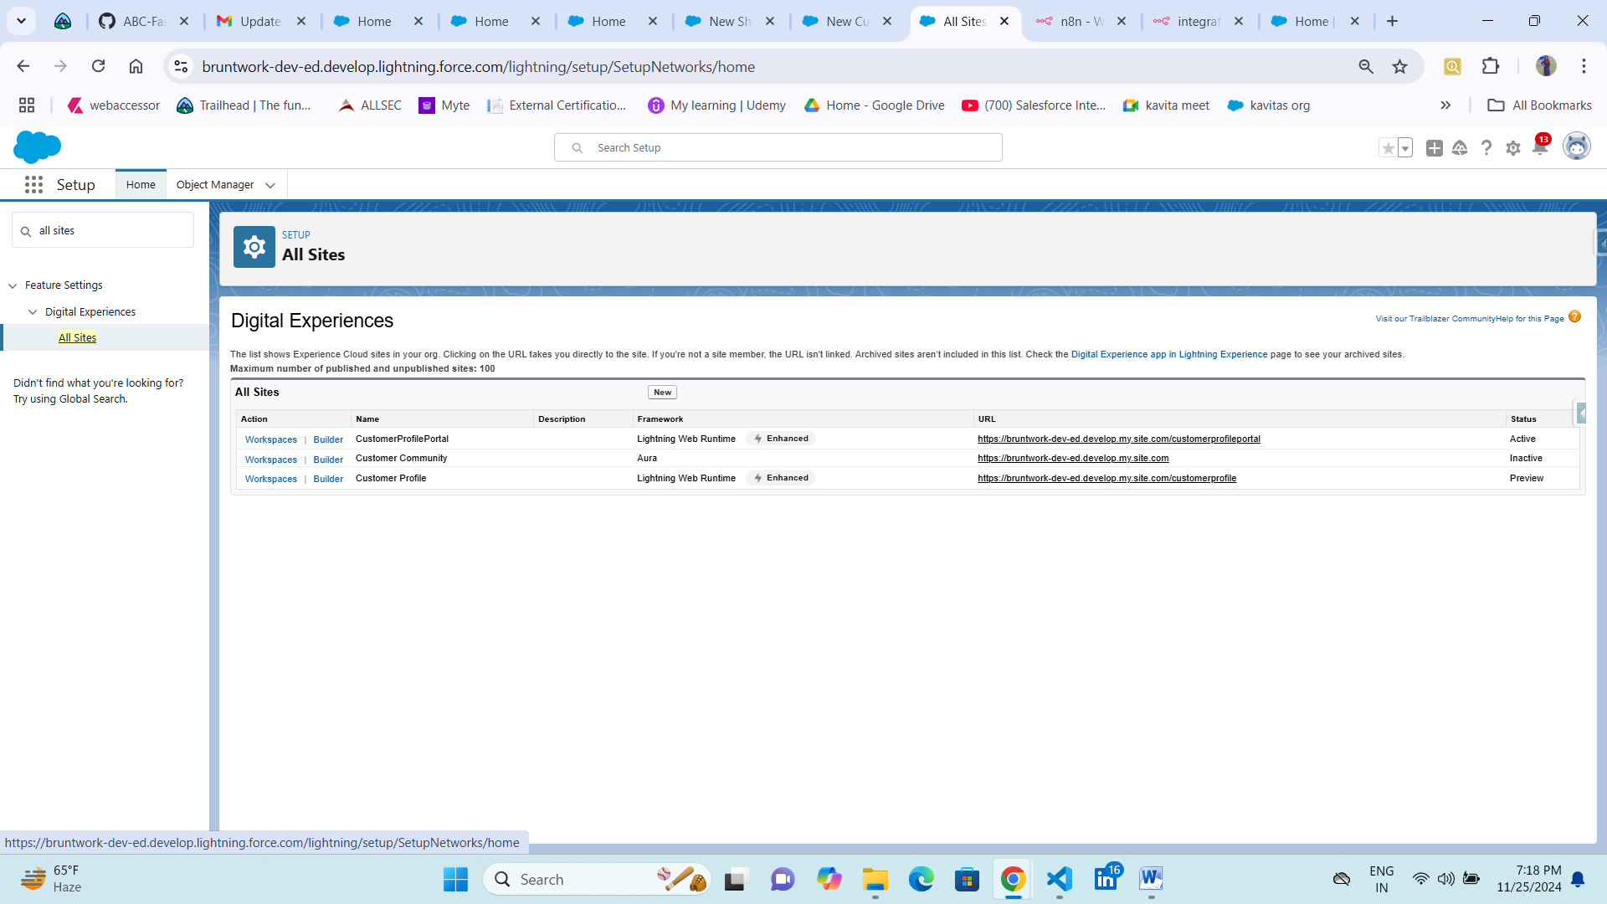 Builder of customer profile portal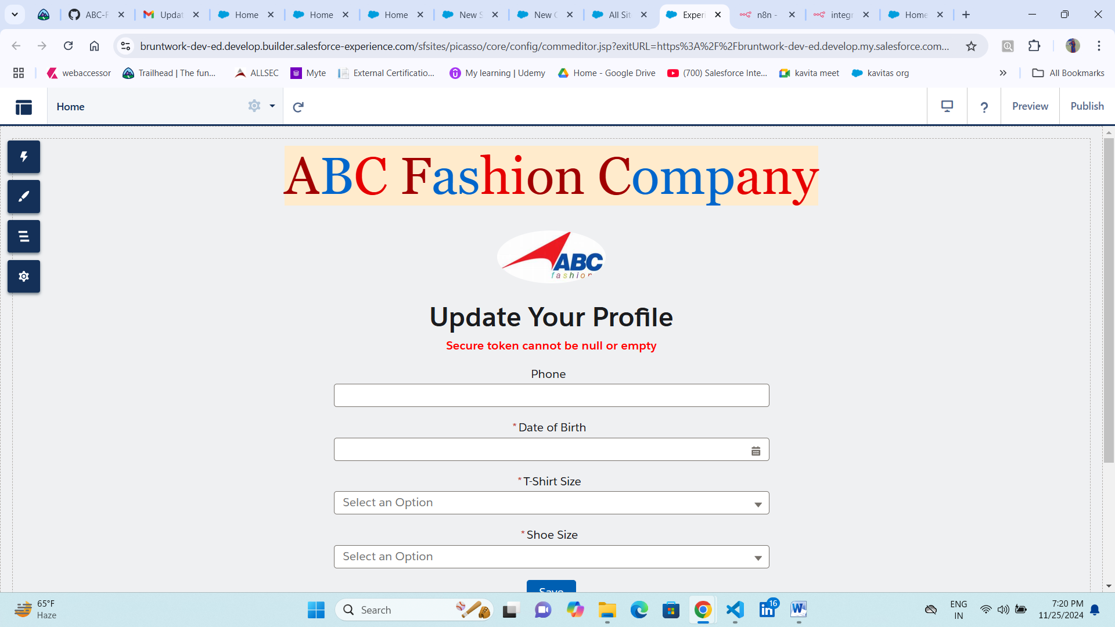 Note:-** secure token is empty that’s why error is coming.Clicking on this link will allow the customer to view their profile and

1. Be able to change their phone number
2. Be able to set their date of birth, t-shirt size and shoe size (all required fields)

Phone Number field is pre-populated if customer want to update other fields are required fields

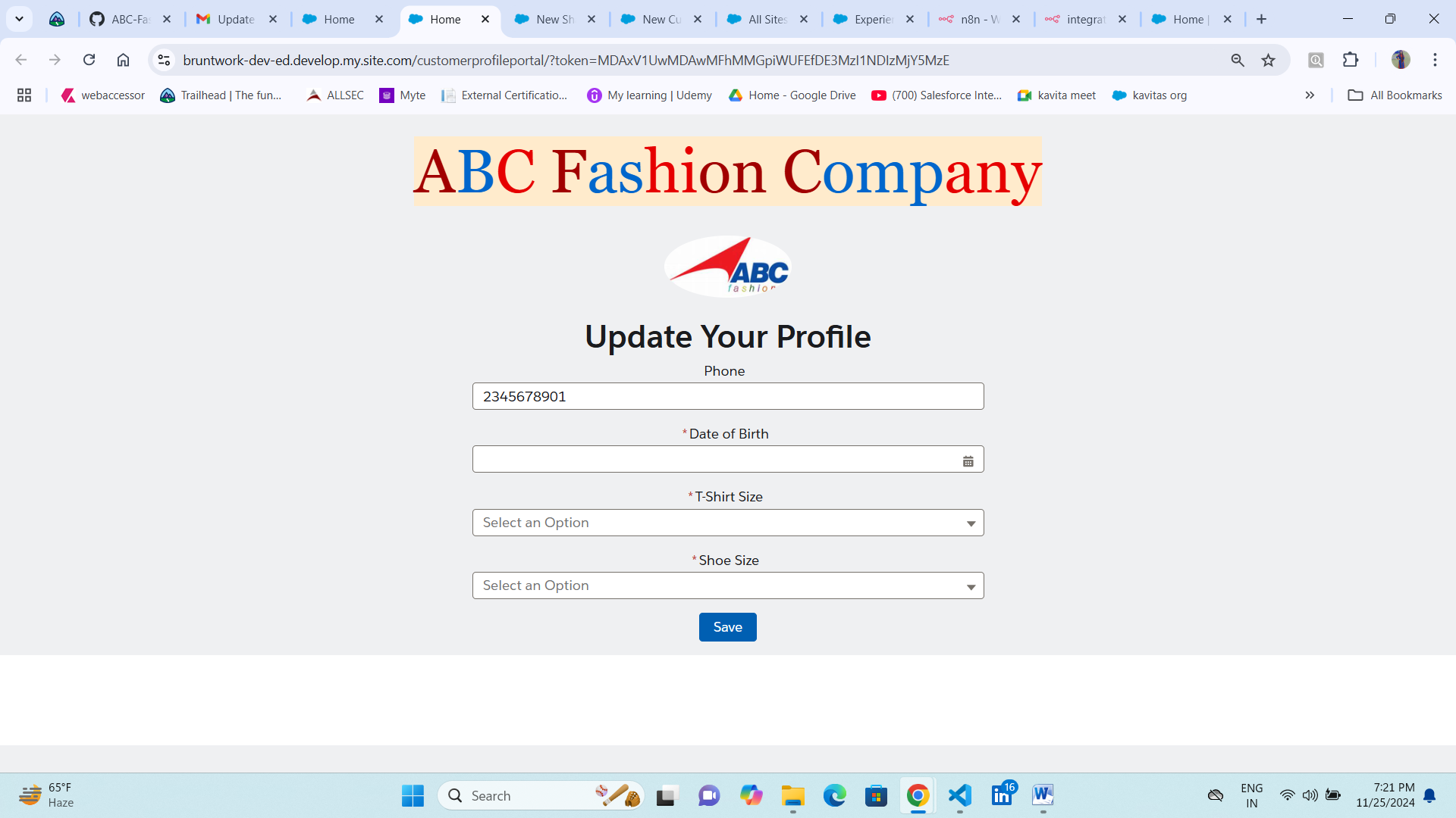

The phone number should only accept 10-digit US/Canadian numbers.”  
  
  
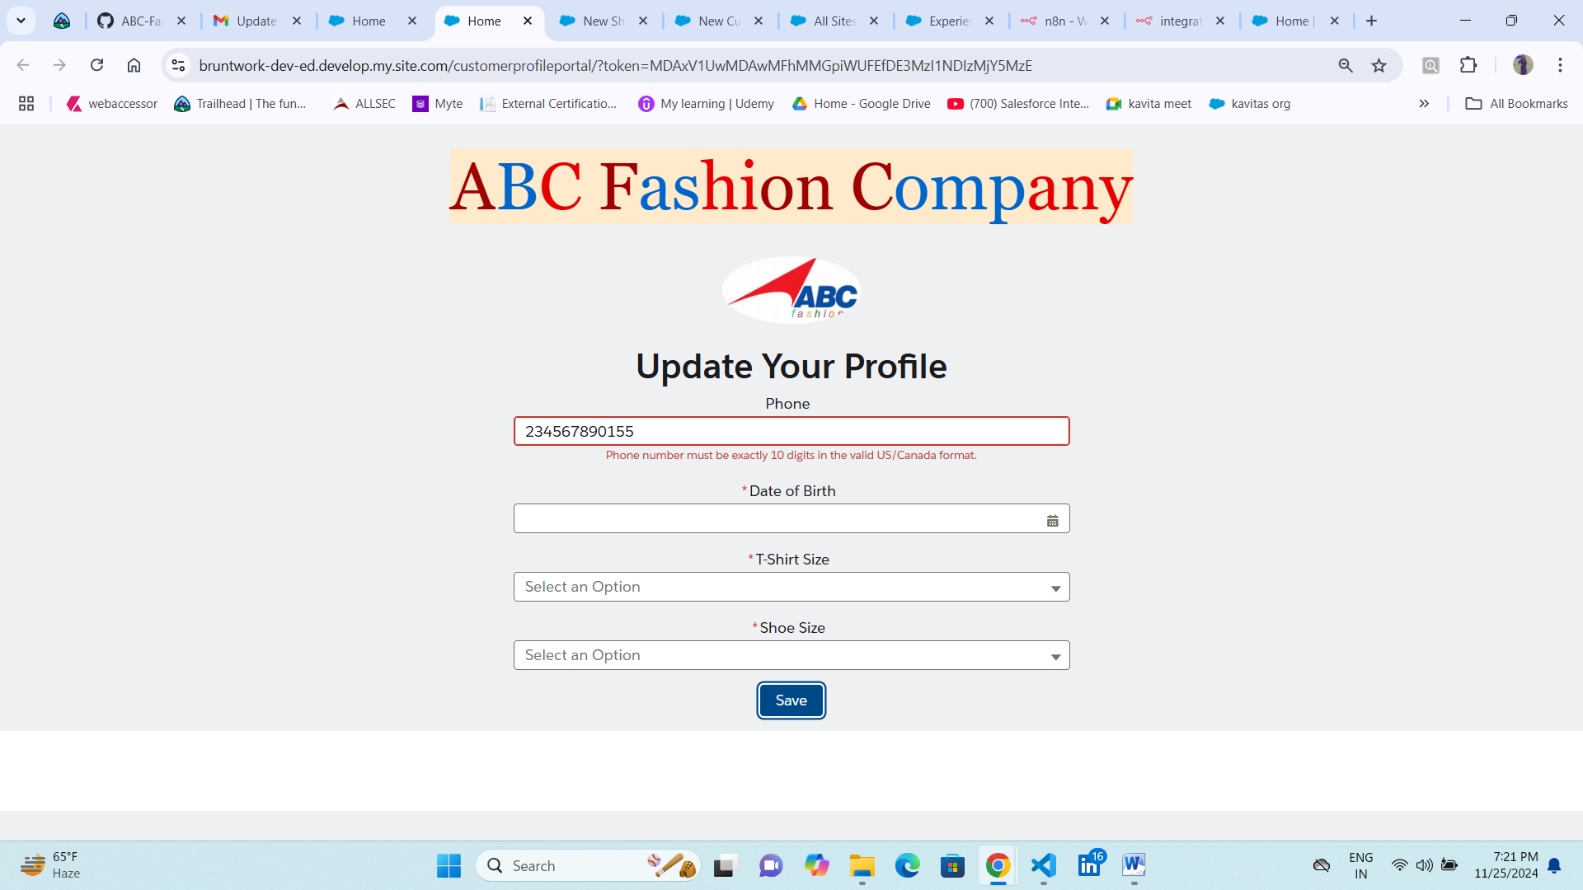  
  
  
  
  
  
  
The t-shirt sizes are: XS, S, M, L, XL, XXL  
  
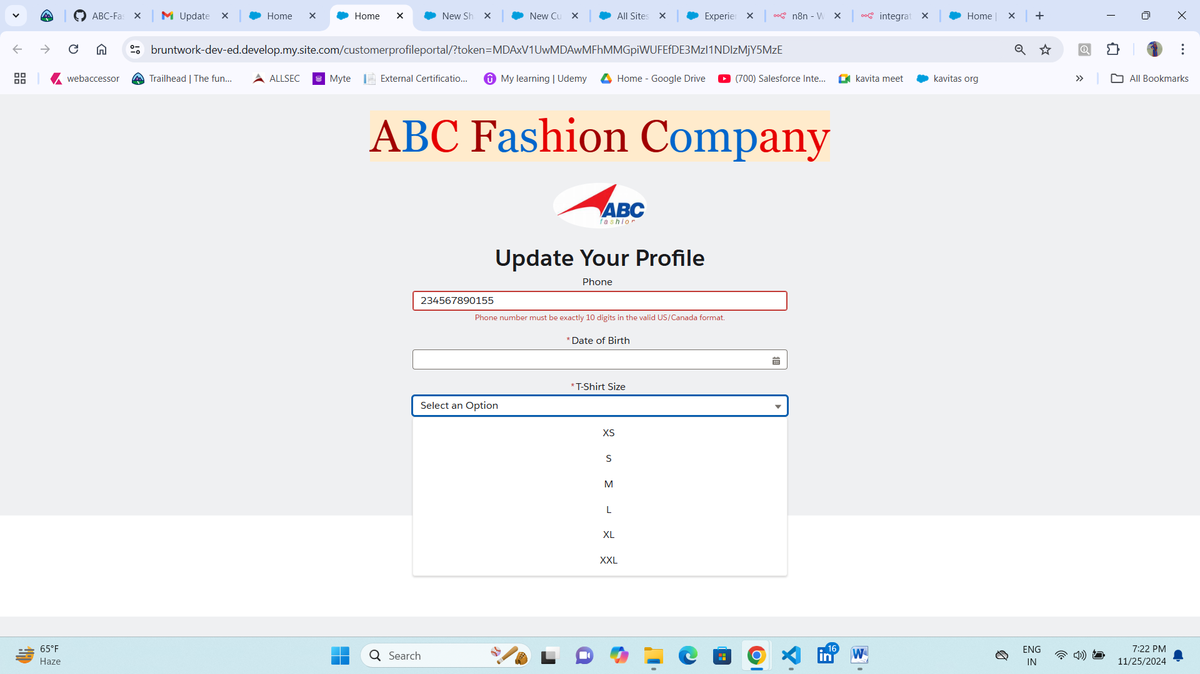

The shoe sizes are between 6 and 16 (inclusive), incrementing by 0.5.

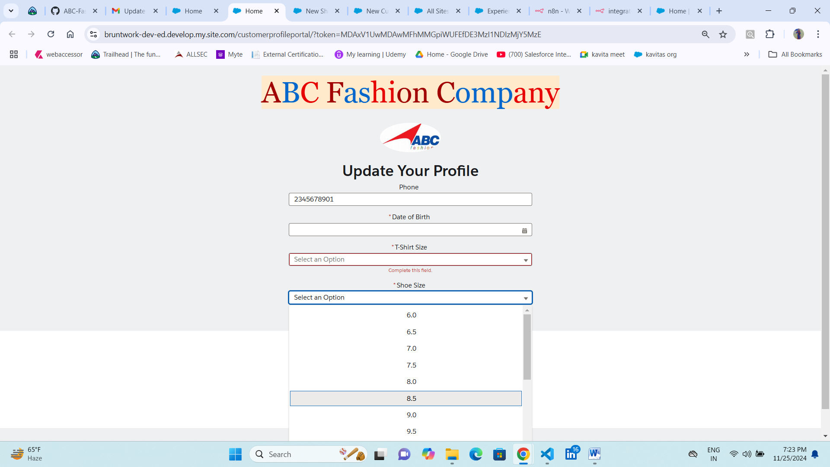  
  
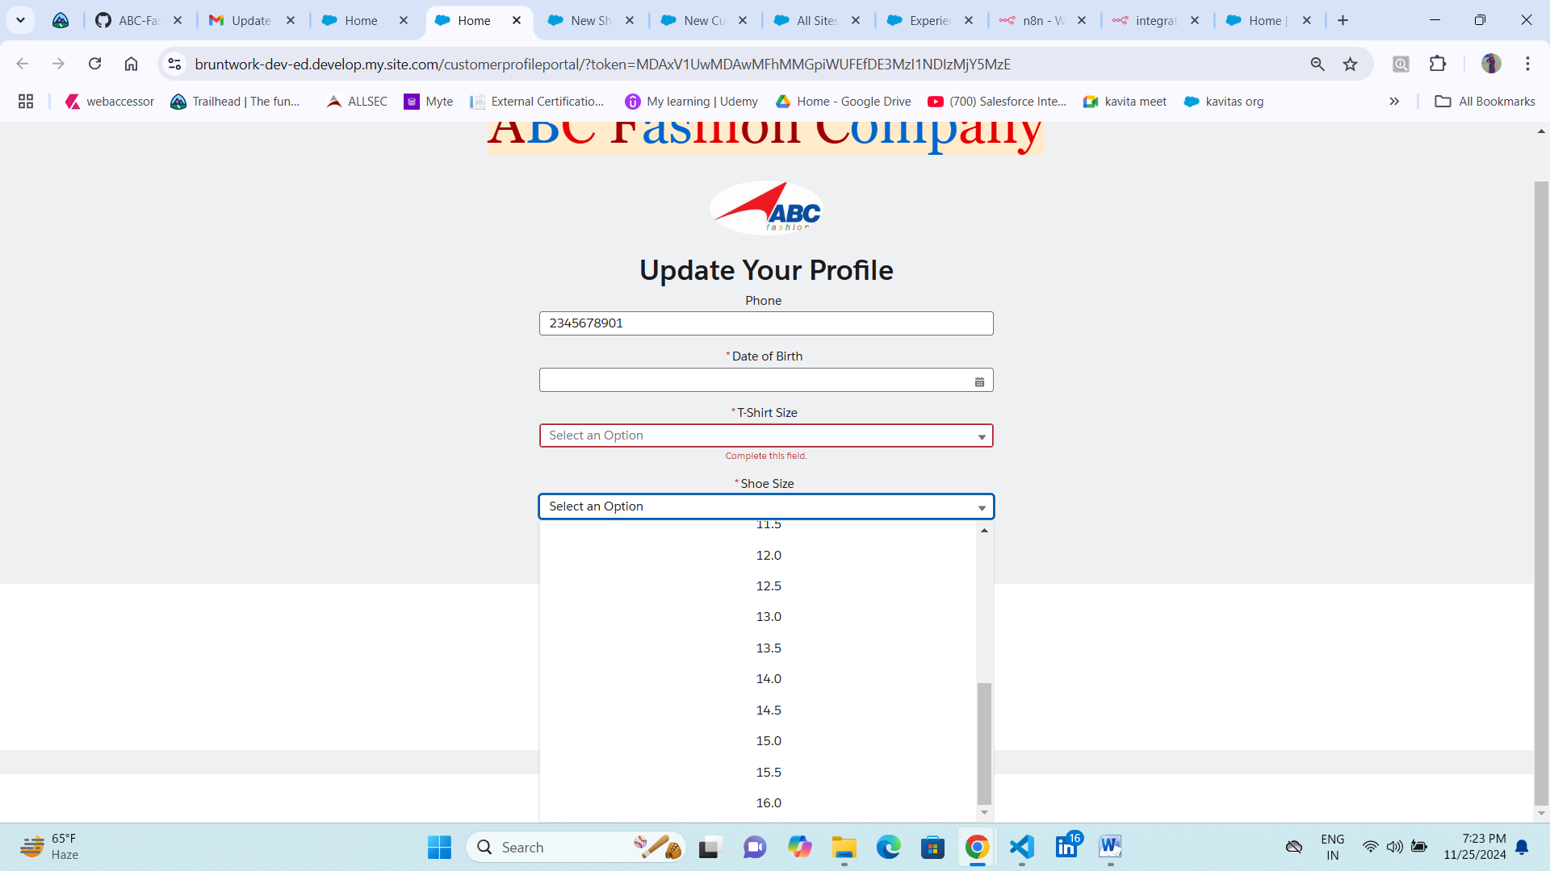

the customer doesn’t have access to Salesforce, so the link needs to be accessible to an unauthenticated user.

**Link is accessible for unauthenticated user**  
https://bruntwork-dev-ed.develop.my.site.com/customerprofileportal/?token=MDAxV1UwMDAwMFhMMGpiWUFEfDE3MzI1NDIzMjY5MzE

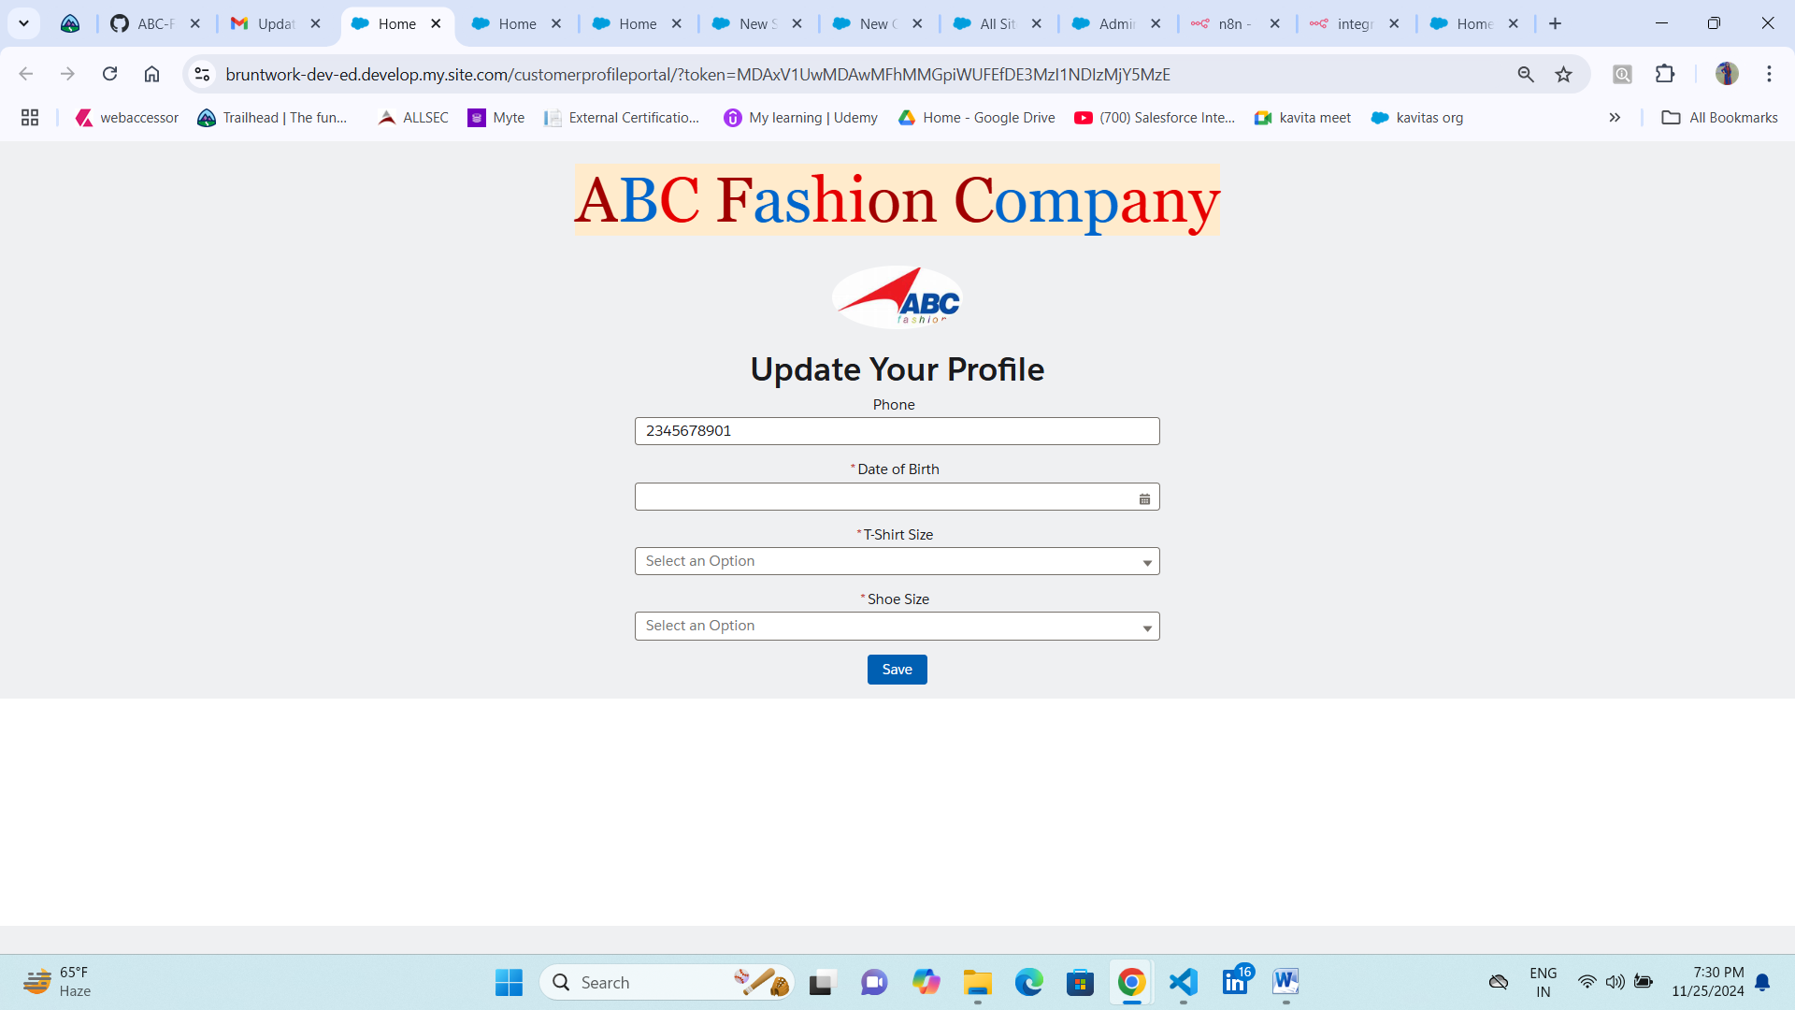Something to note is that Salesforce IDs have a predictable pattern. This means that if the link has the record Id as the only way to identify the customer’s profile, someone could just change a few letters in the URL to start accessing other customer profiles. **Please ensure that a plaintext record Id in the URL is not the sole identifier for the customer profile page.**

I generated a unique token for url   
https://bruntwork-dev-ed.develop.my.site.com/customerprofileportal/?token=MDAxV1UwMDAwMFhMMGpiWUFEfDE3MzI1NDIzMjY5MzE  
 **Step 4:** Once the customer sets their information and it’s saved on Salesforce,

set a custom field called "Profile Completed" to TRUE

Once customer will update profile in the salesforce backend data is being getting saved with updated phone number, T-shirt Size, Shoe-Size, Profile Completed set to true  
  
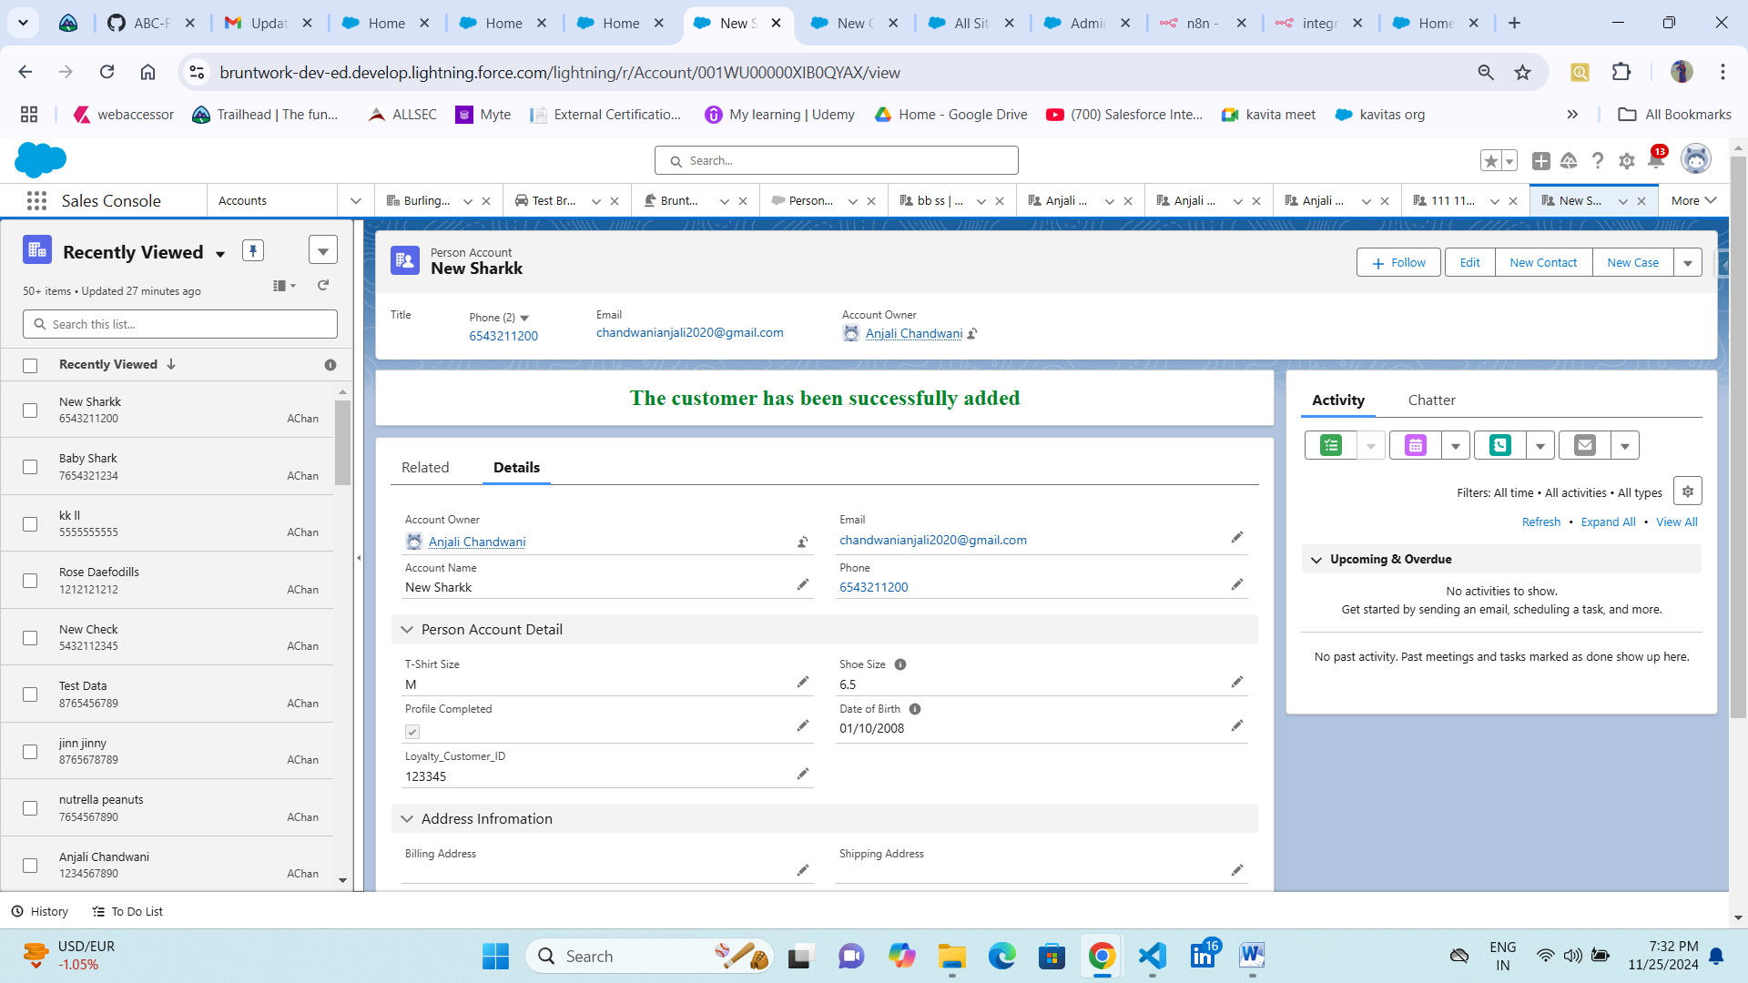  
  
  
When the request is successful, save the customer_id in a custom field (External ID) labelled **Loyalty Customer ID** on the record.

For now I m generating dummy data unitl url have some secret code and consumer key live for the production org and webhook endpoint updated url.  
  
Created dummy customer_id for success its populating once customer get success response as 200 from the webhook url.  
  
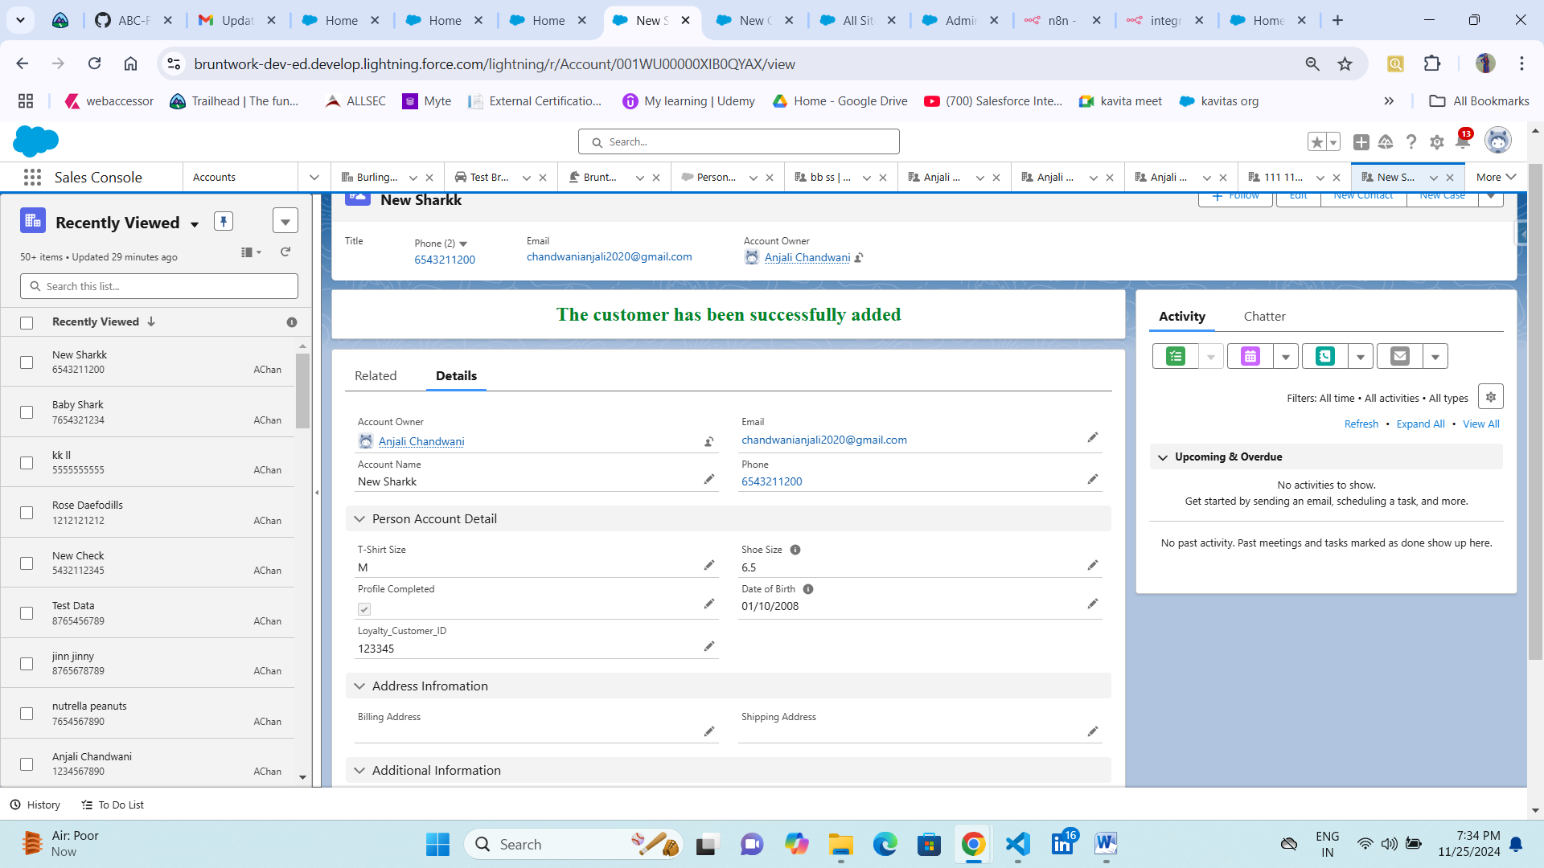

## Here we can look into updated fields after saving the record. To complete the task, please create a user on the existing scratch org user to send verification emails to mkv@destinationrealestate.com. Please set the username to task.<your full name>@destinationrealestate.com. Created the user:- task.anjalichandwani@destinationrealestate.com Configured the Customerprofileportal for unauthenticated user in the Sites. This is the profile created CustomerProfilePortal Profile